Session 3:

CREATE TABLE Restaurants (id int PRIMARY KEY AUTO_INCREMENT,name varchar(25),cuisine varchar(25),rating DECIMAL(2,1),city varchar(20));

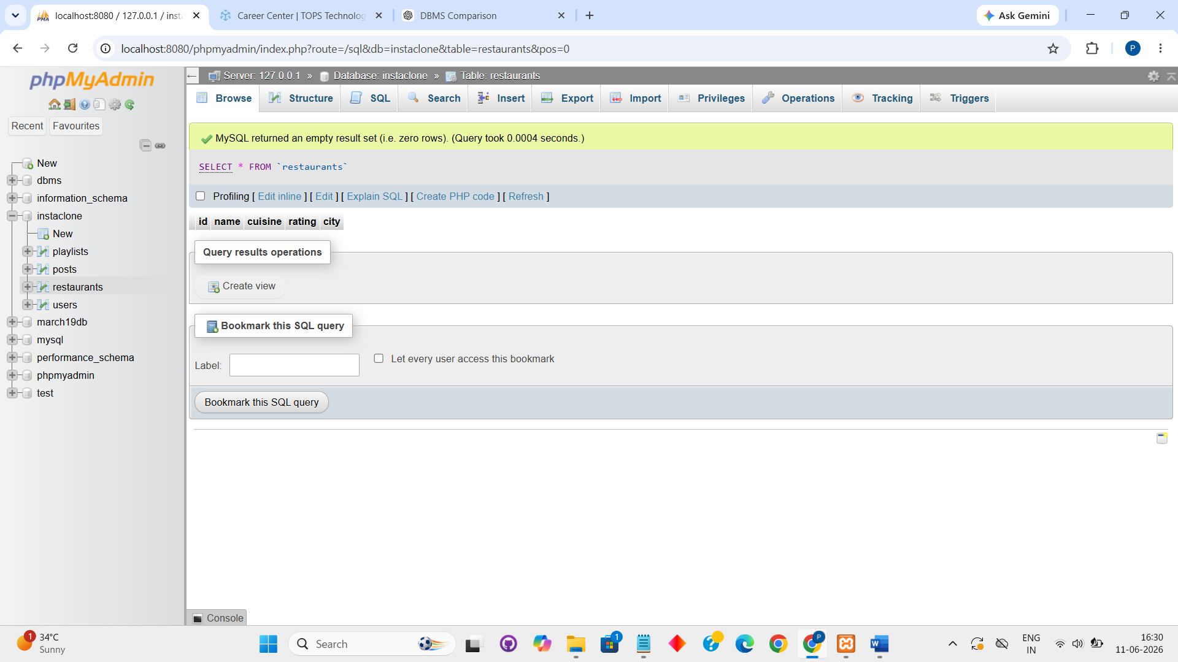

INSERT INTO restaurants(name, cuisine, rating, city)VALUES("Spice Garden", "Indian", "4.5", "Surat");
INSERT INTO restaurants(name, cuisine, rating, city)VALUES("Pizza Hub", "Italian", "4.2", "Mumbai");
INSERT INTO restaurants(name, cuisine, rating, city)VALUES("Dragon Wok", "Chinese", "4.4", "Ahmedabad");
INSERT INTO restaurants(name, cuisine, rating, city)VALUES("Tandoori Palace", "North Indian", 4.7, "Delhi");
INSERT INTO restaurants(name, cuisine, rating, city)VALUES("Ocean Delight", "Seafood", 4.3, "Goa");

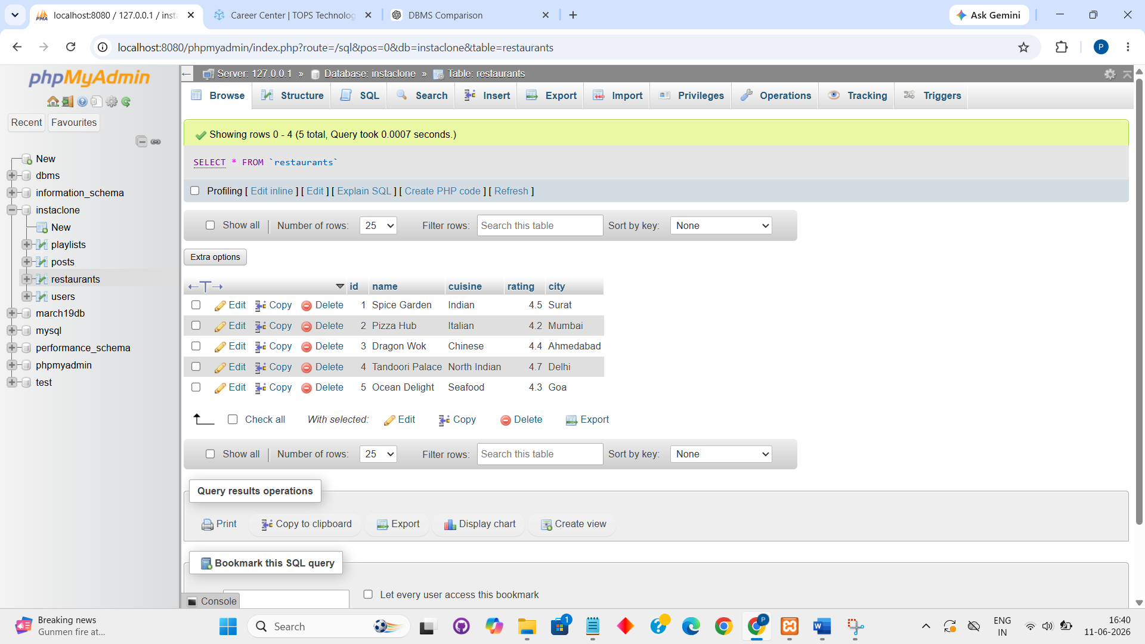

UPDATE restaurants SET rating = "4.7" WHERE name='Spice villa';

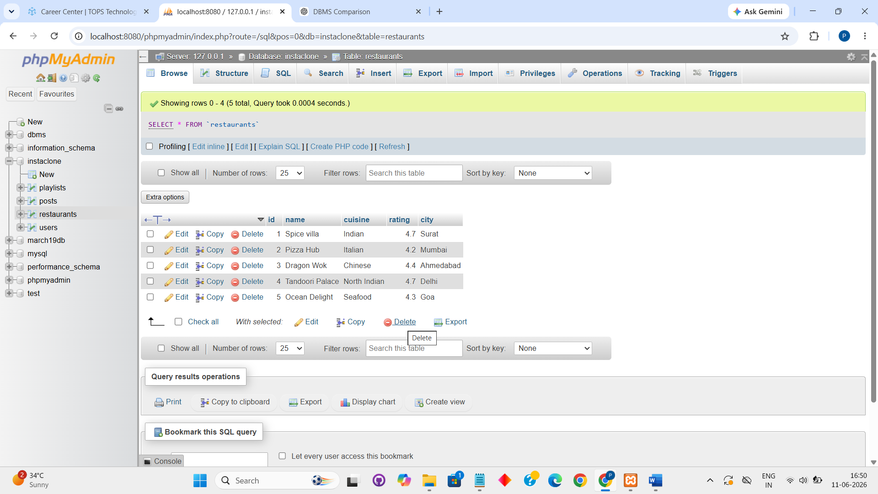

DELETE FROM restaurants WHERE rating<3.5;

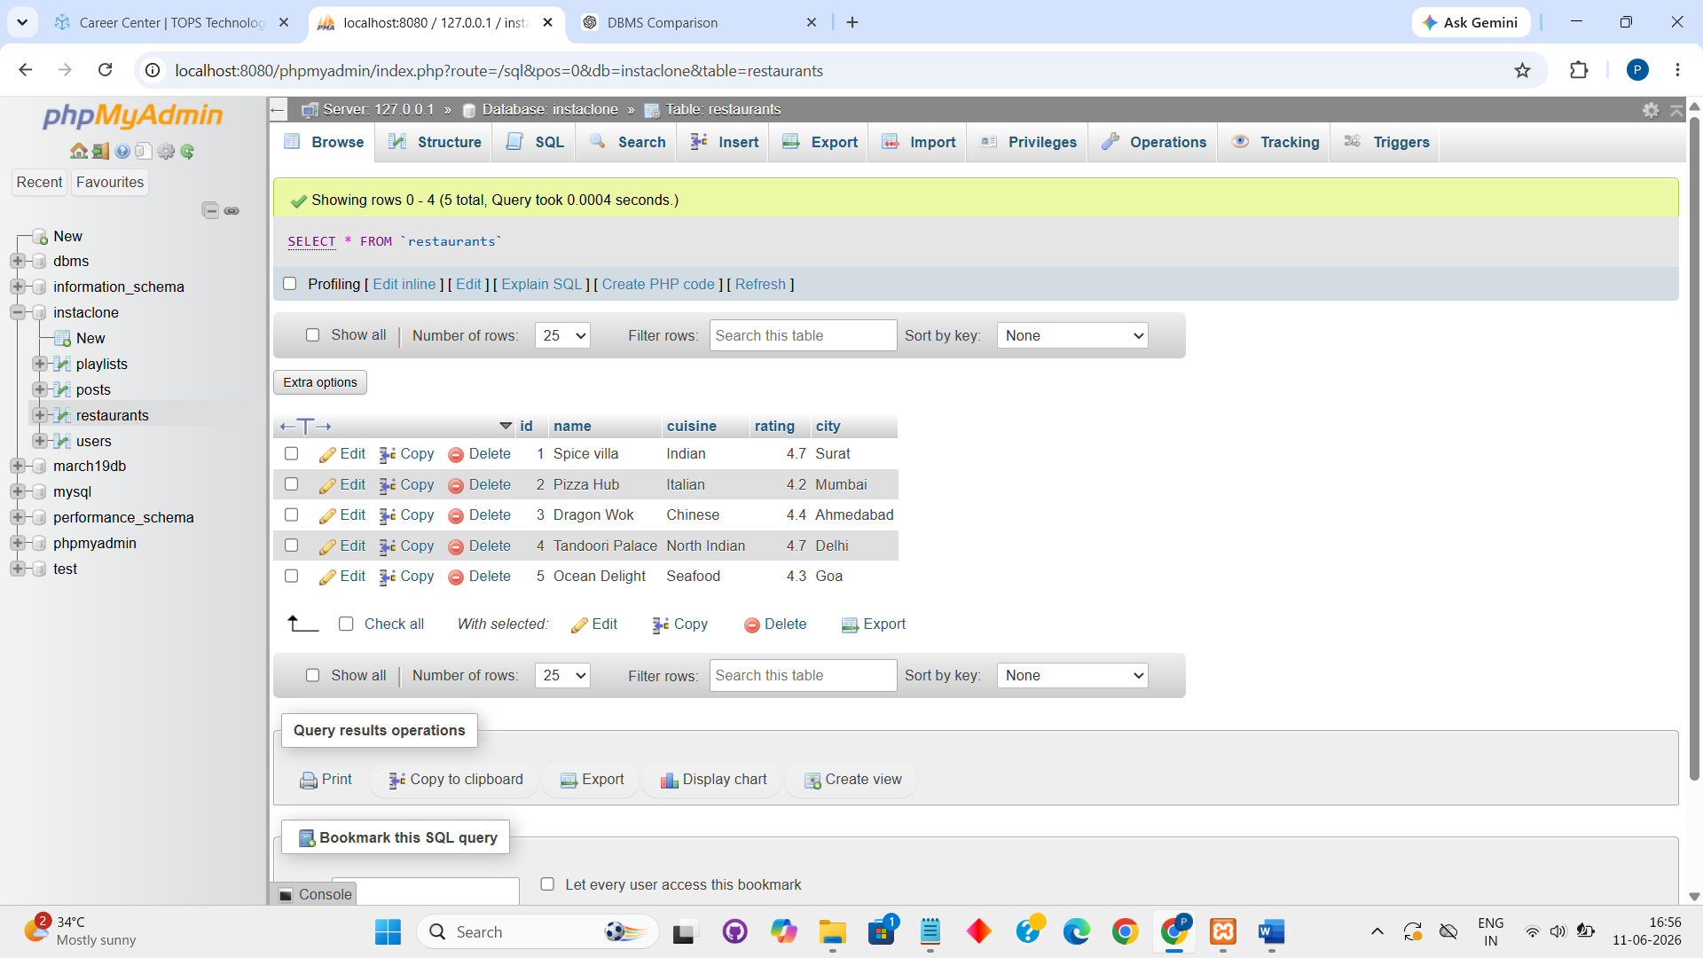

SELECT * FROM restaurants WHERE city='ahmedabad' AND rating>4.0 LIMIT 2;

